Notecards

Group members:

I. Emre Erdem

II. Mustafa Pirbudak

III. Mustafa Can Çalışkan

The Emergence of Autonomous Weapon Systems (Wyatt, 2021)

Humanity, who wanted to develop distant and lethal weapons in order to take less damage and inflict more damage in wars, succeeded in the last century by inventing autonomous weapon systems using powerful computer technology and developments in robotics.

IA1 Summary

Original text:

The history of autonomous weapon systems (AWS) begins with the pursuit of more effective and efficient methods of inflicting violence. In military history, there is a clear pattern of innovations that increase the emotional and physical distance between combatants (Grossman and Christensen, 2007). Historically, this has primarily involved increasing the range and lethality of weapons. This pursuit has fascinated military planners, soldiers and civilian leaders for centuries, driving the development of firearms, artillery and, of course, military robotics. Although the scale of the remote operation was initially limited by technological progress to relatively rudimentary radio control, wire control and/or teleoperation, the rise of satellite technology, increasingly powerful computing technology and advancements in robotics have propelled the human combatant further from the immediate battlefield. An effective analysis of the impact of autonomous weapon systems must therefore start by examining the historical evolution of remote-operated weapons.

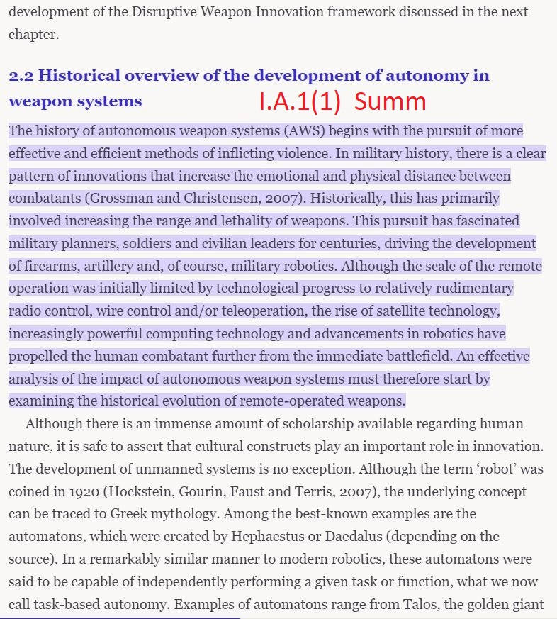

Development Until Today (Wyatt, 2021)

Nikola Tesla, who was the first to demonstrate that vehicles could be remotely controlled by radio signal and emphasized their use in warfare, believed that remotely controlled robots were the future of conflict.

IA2 Paraphrase

Original text:

The advent of radio control was a major step in the development of unmanned military technology. In the late 1890s, Nikolas Tesla demonstrated the capacity of remote-controlling vehicles by radio signal. With his trademark showmanship, Tesla used radio control to make a large iron ship follow shouted directions from the crowd (Finn and Scheding, 2012). Teslas stated goal was to militarise this advancement, specifically for use in the SpanishAmerican War. Tesla had come to the belief that Telautomats (remotely controlled robots) were the future of conflict and, in a remarkably similar leap of logic to Richard Gatling, believed that they would make the conflict so terrible that states would no longer start wars (Chivers, 2010).

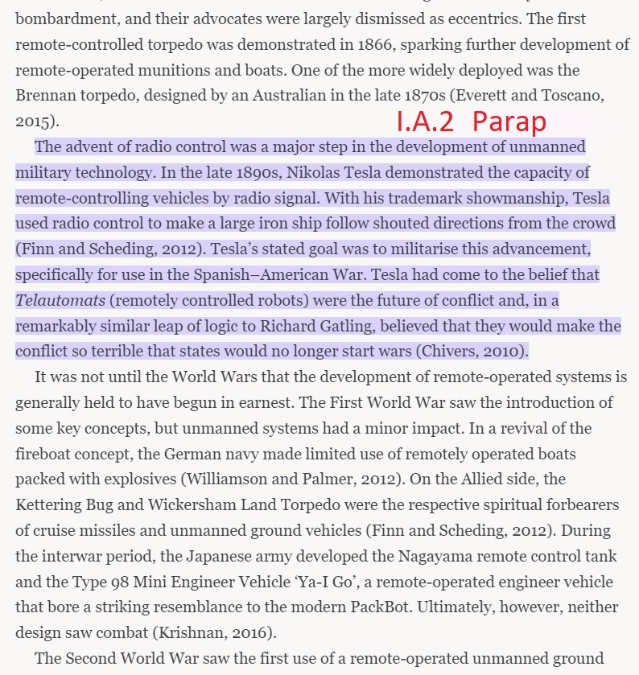

Modern Day Lethal Machines (Jha, 2016)

Today, autonomous weapons, which have different shapes and sizes according to their purposes, are deployed for different tasks in the armed forces of many countries on land, in the air, on the water surface or underwater.

IB1 Paraphrase

Original text:

A few militaries which have developed automated systems are taking the help of robots for risky work. The automated systems used in the armed forces are usually deployed within integrated systems. These robotic systems have different shapes and sizes, according to their purposes, and may be fully autonomous machines or remote-controlled. They may be engaged in different missions, including surveillance, explosive ordnance disposal (EOD), logistics support, search and rescue missions, and combat role. The automated systems integrated in the armed forces could be land-based, air-based, made for operating on the surface of water or underwater, or operated remotely by humans.

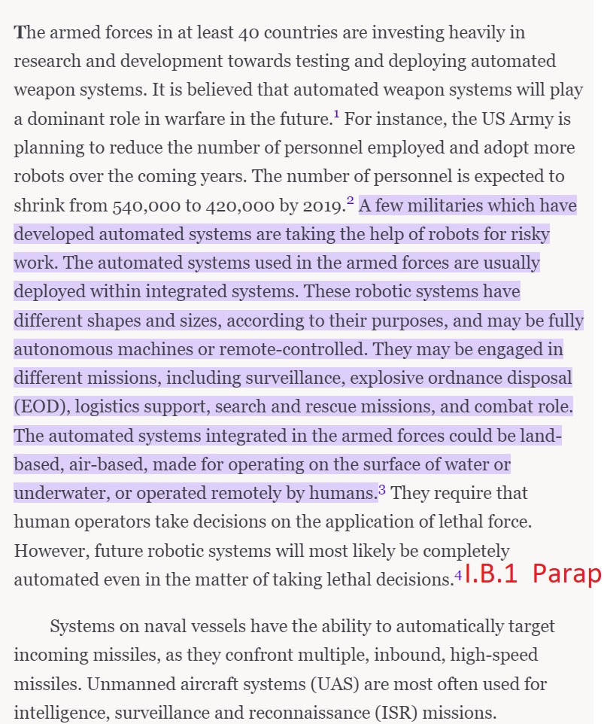

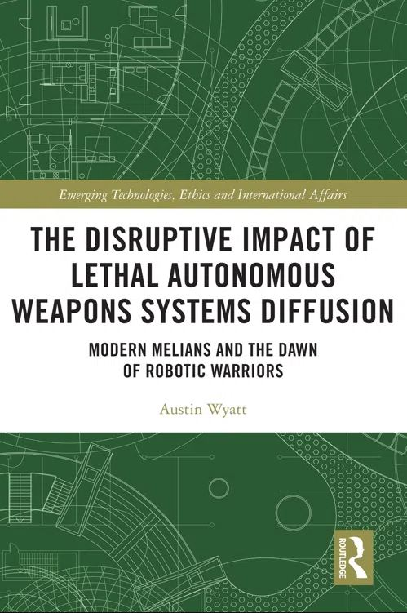

<https://www.perlego.com/book/2912464/the-disruptive-impact-of-lethal-autonomous-weapons-systems-diffusion-modern-melians-and-the-dawn-of-robotic-warriors-pdf>

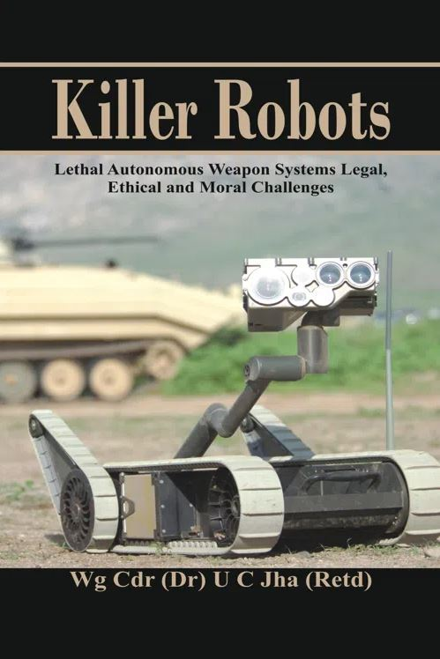

<https://www.perlego.com/book/2012019/killer-robots-lethal-autonomous-weapon-systems-legal-ethical-and-moral-challenges-pdf>

|  |
| --- |
| (Nyugen et al., 2015)  Inefficacy In Object Recognition  According to an experiment done by Nyugen et. al. (2015), these systems are able to be deceived by the enemy because the machines use a similar way of coding the image they see around them. The images encoded by some machines can mislead targeted machines by making them believe that the image they created is something else entirely, the images can convince the targeted machine by %99.99 (p.6).  Summary  IIA1 |

Original text:

The results of the previous section suggests that there are discriminative features of a class of images that DNNs learn and evolution exploits. One question is whether different DNNs learn the same features for each class, or whether each trained DNN learns different discriminative features. One way to shed light on that question is to see if images that fool one DNN also fool another. To test that, we evolved CPPN-encoded images with one DNN (DNNA) and then input these images to another DNN (DNNB). We tested two cases: (1) DNNA and DNNB have identical architectures and training, and differ only in their randomized initializations; and (2) DNNA and DNNB have different DNN architectures, but are trained on the same dataset. We performed this test for both MNIST and ImageNet DNNs.

Images were evolved that are given 99.99% confidence scores by both DNNA and DNNB. Thus, some general properties of the DNNs are exploited by the CPPN-encoded EA.

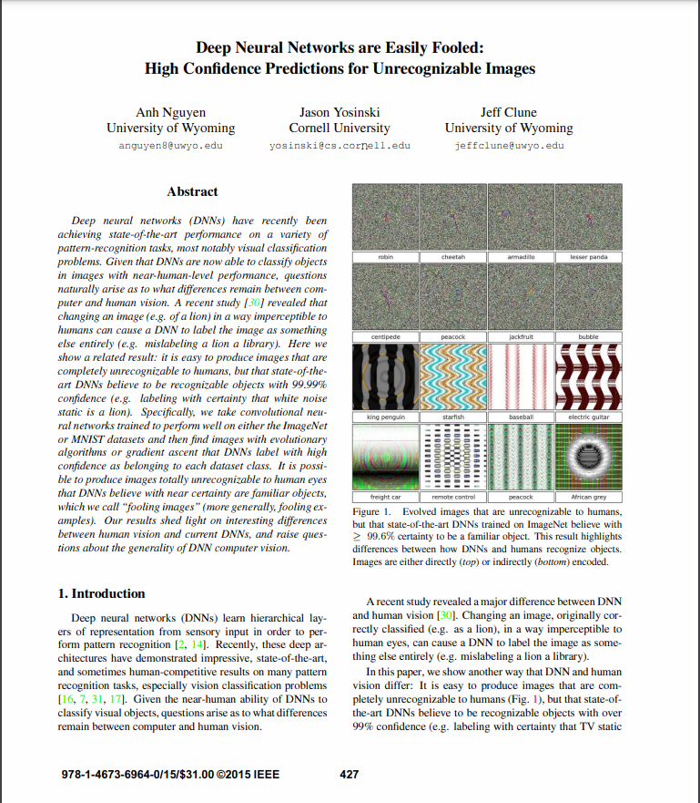

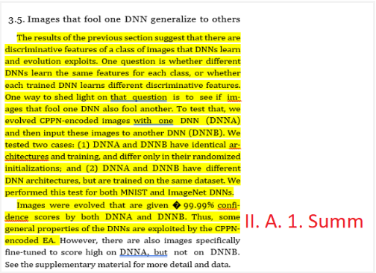

|  |
| --- |
| (Peterson, 2011)  Manipulation By Enemy  Peterson (2011) states that an American sentinel drones link to its home base was cut off and the drone was hijacked by the Iranian army. They successfully landed the drone at one of their airports instead of the original base of the drone which is in Afghanistan (para. 2).  Paraphrase  IIB1 |

Original text:

Iranian electronic warfare specialists were able to cut off communications links of the American bat-wing RQ-170 Sentinel, says the engineer, who works for one of many [Iranian military](https://www.csmonitor.com/tags/topic/Iranian+Armed+Forces" \t "_self) and civilian teams currently trying to unravel the drone’s stealth and intelligence secrets, and who could not be named for his safety.

Using knowledge gleaned from previous downed American drones and a technique proudly claimed by Iranian commanders in September, the Iranian specialists then reconfigured the drone's GPS coordinates to make it land in Iran at what the drone thought was its actual home base in [Afghanistan](https://www.csmonitor.com/tags/topic/Afghanistan" \t "_self).

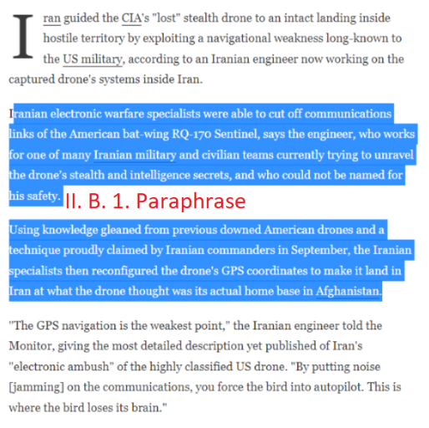

|  |
| --- |
| (Sytas, 2022)  The damage of cyber attacks  An article published by Andrius Sytas relates Russian hacker groups' attack in June 2022 on Lithuanian websites. Their attack on Lithuanian websites has caused the distortion of 1.652 web resources (2022).  Paraphrase  IIB1 |

Original text:

 Lithuanian state and private websites were targeted on Monday by Russian hackers who claimed the attack was retaliation for Vilnius's decision to cease the transit of some goods under European Union sanctions to Russia's Kaliningrad exclave.

Lithuania's tax authority said in a statement it had halted all activities due to an unusually large number of attempts to connect to its systems, although all data was safe.

"The main targets are state institutions, transport institutions, media websites," deputy Defence Minister Margiris Abukevicius said, in another sign of deteriorating relations between Baltic NATO country Lithuania and neighbouring Russia because of Moscow's invasion of Ukraine in February.

Russian hacker group Killnet claimed responsibility for what is known as a distributed denial of service (DDoS).

"The attack will continue until Lithuania lifts the blockade," a Killnet spokesperson said. "We have demolished 1,652 web resources. And that's just so far."

Kaliningrad is sandwiched between EU and NATO members Poland and Lithuania and supplied by rail via Lithuanian territory.

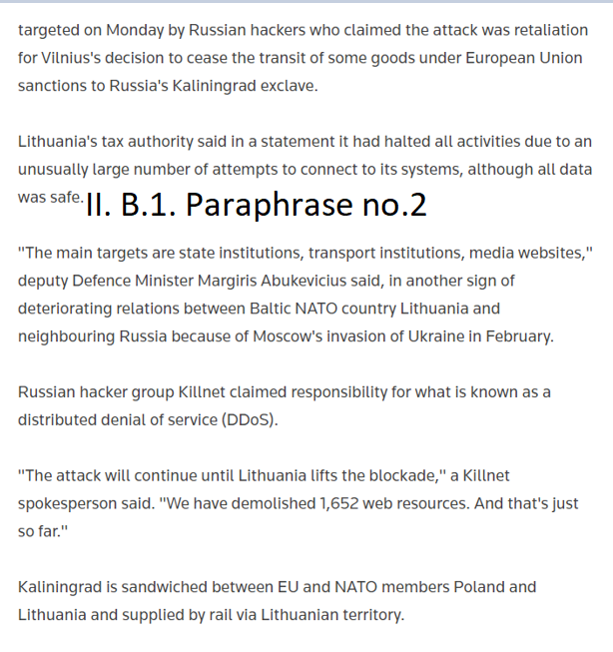

Accountability (Scharre, 2018, p. 328)

Scharre (2018) expresses that military and defense contractors are often exempt from liability during times of conflict (p. 328).

Comment: This implies that engineers who produce autonomous weapons cannot be judged.

IIIA1 Paraphrase

Original text:

In war, though, military and defense contractors are generally shielded from civil liability.

Moral responsibility for killing (Scharre, 2018, p. 347)

Using an experiment result, Scharre (2018) expressed that if soldiers believe that they transferred their moral responsibility of killing to autonomous weapons, they can behave more senseless, and this situation may cause more killing. (p. 347)

IIIA2 Summary

Original text:

Autonomous weapons could also lead to an off-loading of moral responsibility for killing. Grossman found that soldiers were more willing to kill if responsibility for killing was diffused. While only 15–20 percent of World War II riflemen reported firing at the enemy, firing rates for machine-gun crews were much higher, nearly 100 percent. Grossman argued that each team member could justify his actions without taking responsibility for killing, which only occurred because of the collective actions of the team. The soldier feeding the ammunition wasn’t killing anyone; he was only feeding ammunition. The spotter wasn’t pulling the trigger; he was just telling the gunner where to aim. Even the gunner could absolve himself of responsibility; he was merely aiming where the spotter told him to aim. Grossman explained, “if he can get others to share in the killing process (thus diffusing his personal responsibility by giving each individual a slice of the guilt), then killing can be easier.” Grossman argued that much of the killing in war has historically been done by crew-served weapons: machine guns, artillery, cannon, and even the chariot. If the person launching the autonomous weapon felt that the weapon was doing the killing, the lessening of moral responsibility might lead to more killing.

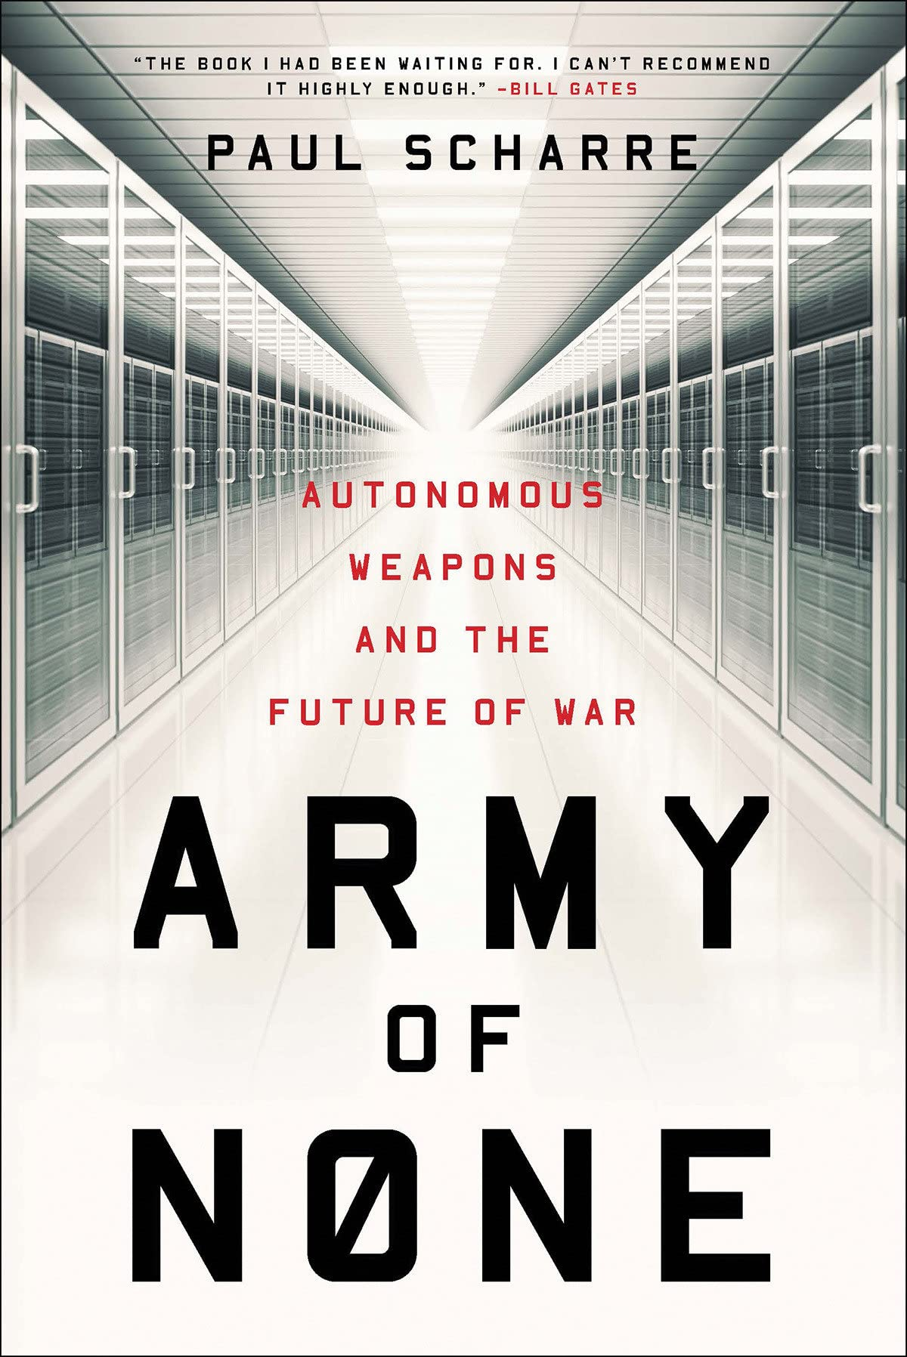

**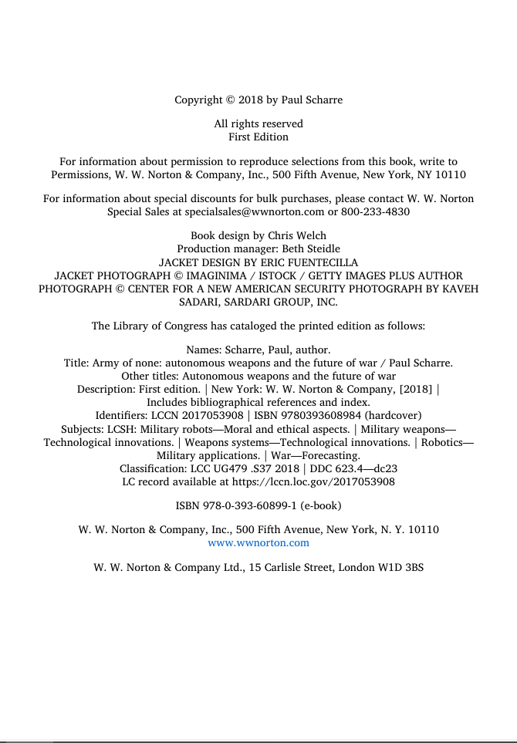**

**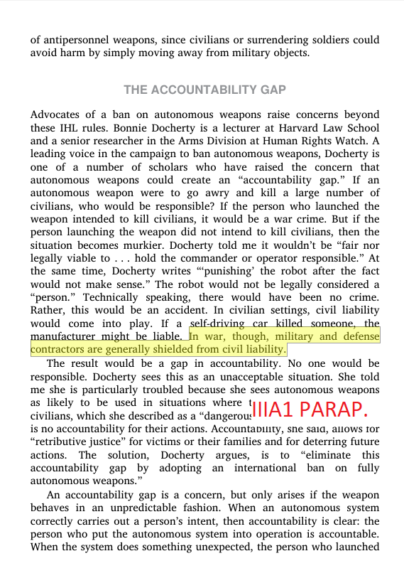**

**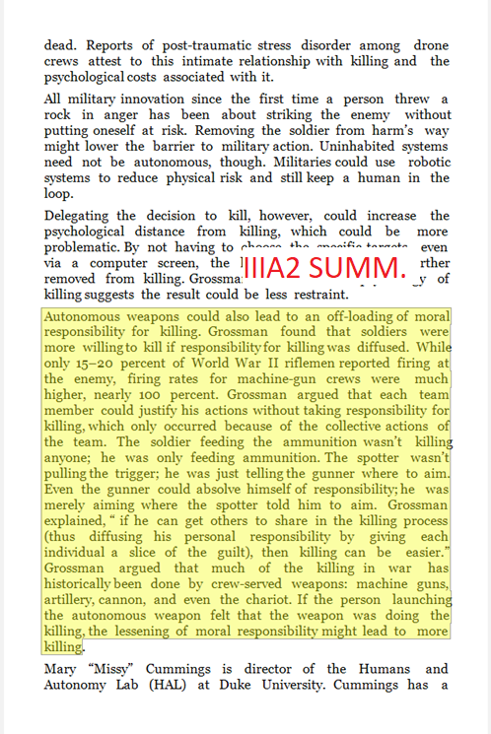**

Accountability gap (Crootof, 2016, pp. 1391-1392)

As stated by Crootof (2016), in 1988, an Iranian commercial plane was shot down by a US warship which was operated in a semiautonomous mode. Neither operators nor commanders were found guilty, but US Government paid $61.8 million to the victims’ relatives without admitting its mistake (pp. 1391-1392).

Comment: From the example given above, it is clear that involving autonomous weapons in the accident created an accountability gap.

IIIA1a Summary

Original text:

In practice, states often refuse to take responsibility for actions akin to war torts. Consider the downing of Iran Air Flight 655. Not only was this incident notable as one of the most deadly in aviation history—290 passengers and crew members, including 66 children, died—it also involved an autonomous weapon system, albeit one operated in a semiautonomous mode.240 In 1988, as the Iran–Iraq War was ending, the USS Vincennes was patrolling in the Strait of Hormuz.241 The Vincennes was outfitted with the then-brand-new Aegis Combat System.242 On July 3, after taking fire from gunboats, the Vincennes pursued them into Iranian territorial waters. While there, the Aegis system mislabeled a passenger jet as an F-14 Tomcat. Despite hard data that suggested the plane was not a threat, the crew nonetheless authorized the Aegis to fire, resulting in the deaths of all 290 individuals on board.243 In 1991, Iran brought suit in the International Court of Justice, claiming that the United States had violated numerous treaty obligations and Article 2(4) of the U.N. Charter.244 Iran demanded declaratory relief, an order that the United States cease all unlawful conduct, and reparation for damages.245 The United States contested the International Court of Justice’s jurisdiction under treaty and customary law, but in 1996 it agreed to settle for a $61.8 million compensation payout to the victims’ families.246 The United States never admitted fault, and no one on board the ship or within the Navy was ever publicly punished.

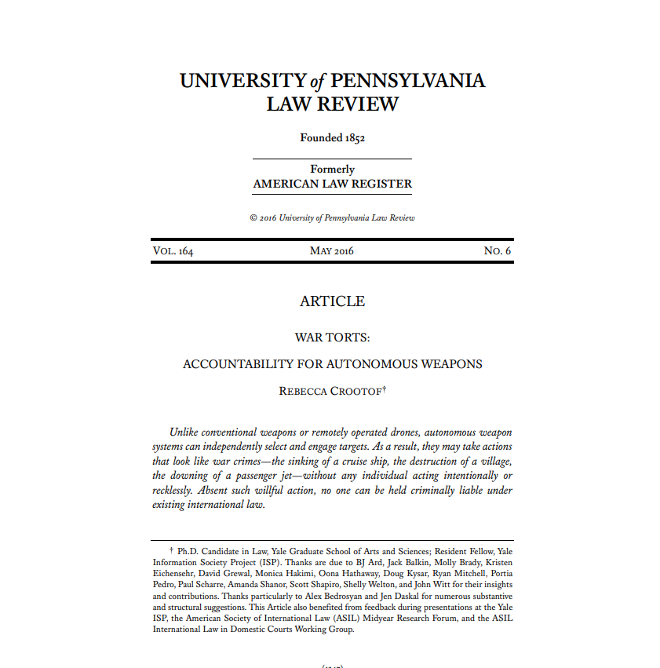

**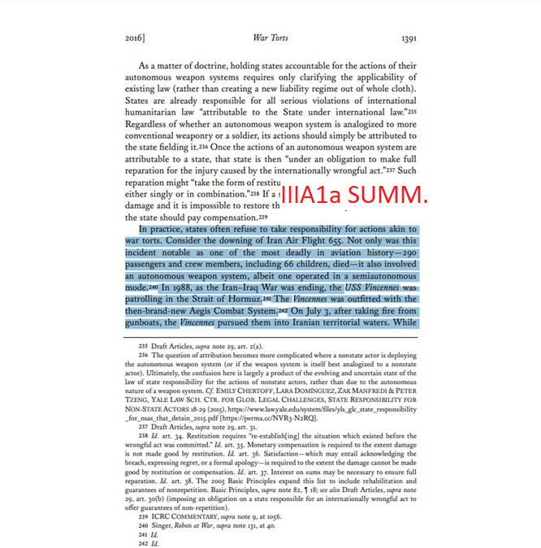**

**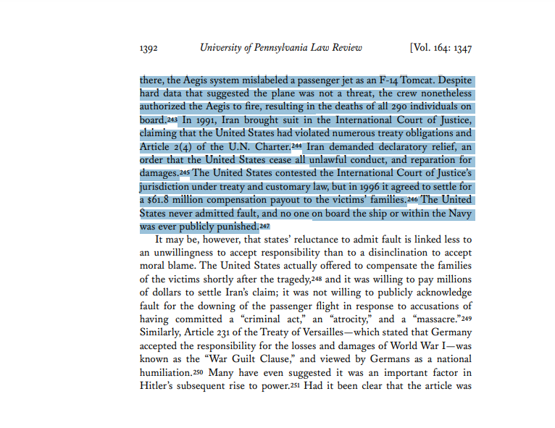**

World War II (Grossman, 2009, pp. 37-38)

Army psychologist Grossman (2009) explains that during World War II, army historian S. Marshall interviewed soldiers who have come off the front lines, and found that 15 to 20 percent of soldiers were actually shooting at the enemy (pp. 37-38).

IIIA3a Summary

Original text:

During World War II U.S. Army Brigadier General S. L. A. Marshall asked these average soldiers what it was that they did in battle. His singularly unexpected discovery was that, of every hundred men along the line of fire during the period of an encounter, an average of only 15 to 20 “would take any part with their weapons.” This was consistently true “whether the action was spread over a day, or two days or three.” Marshall was a U.S. Army historian in the Pacific theater during World War II and later became the official U.S. historian of the European theater of operations. He had a team of historians working for him, and they based their findings on individual and mass interviews with thousands of soldiers in more than four hundred infantry companies, in Europe and in the Pacific, immediately after they had been in close combat with German or Japanese troops. The results were consistently the same: only 15 to 20 percent of the American riflemen in combat during World War II would fire at the enemy.

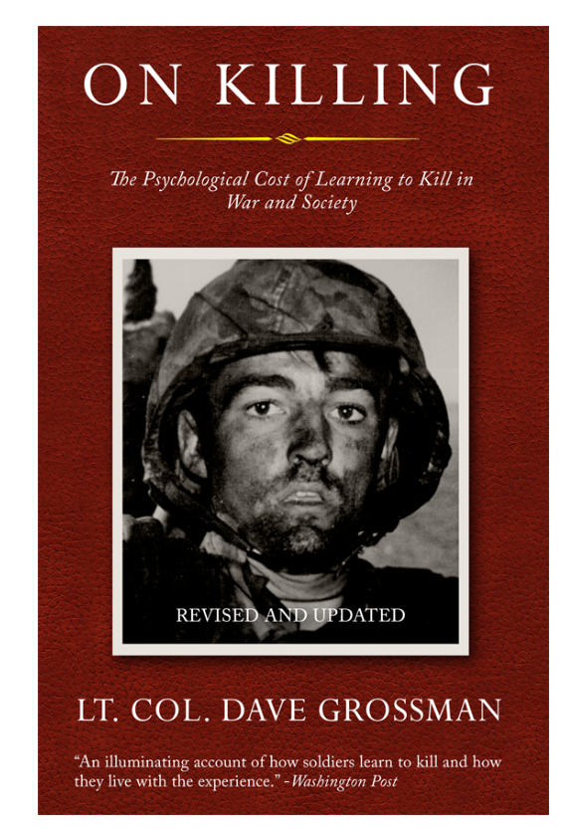

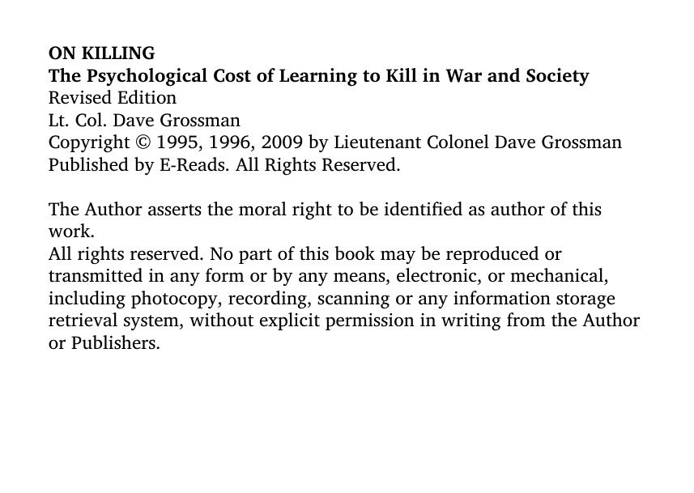

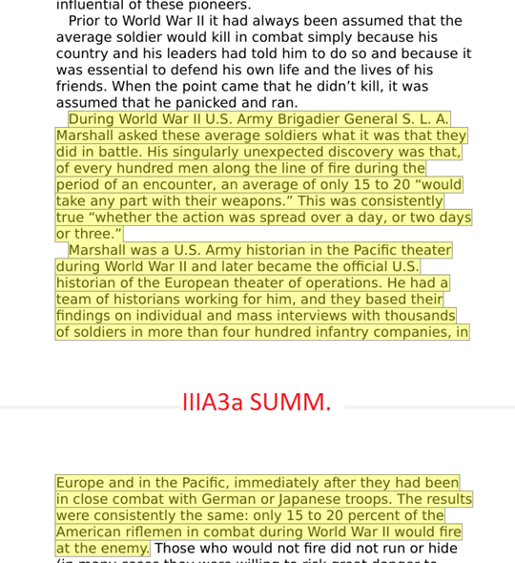

The value of human life (Goose & Wareham, 2017)

As Goose and Wareham stated, autonomous weapons would be disrespectful to human life since they have the authority to decide killing even though they are incapable of understanding the worth of life. (2017)

IIIA3 Paraphrase

Original text:

Fully autonomous weapons would also undermine human dignity, because as inanimate machines they could not understand or respect the value of life, yet they would have the power to determine when to take it away.

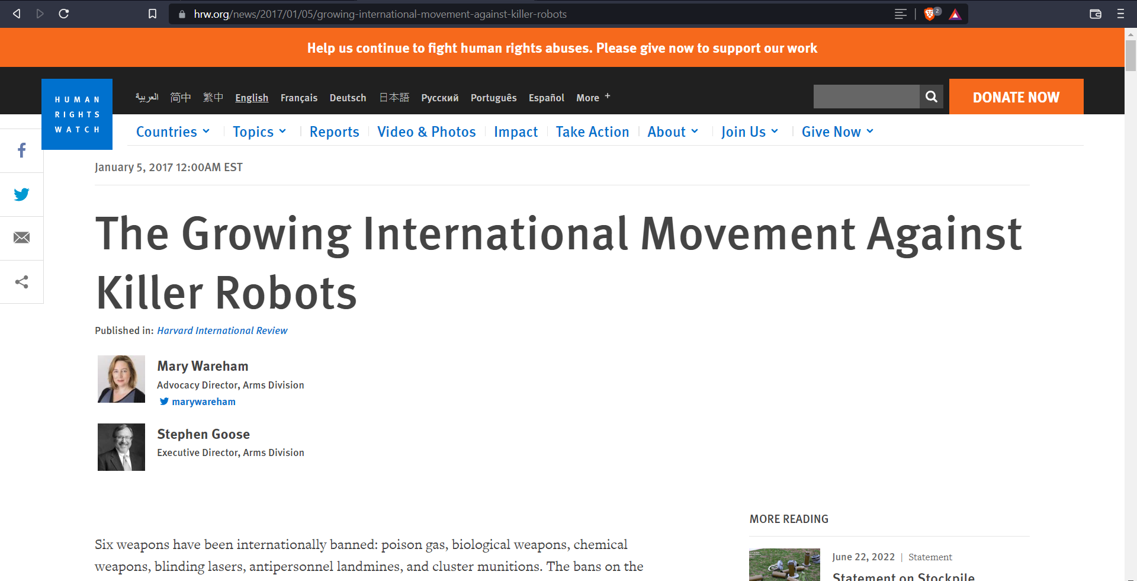

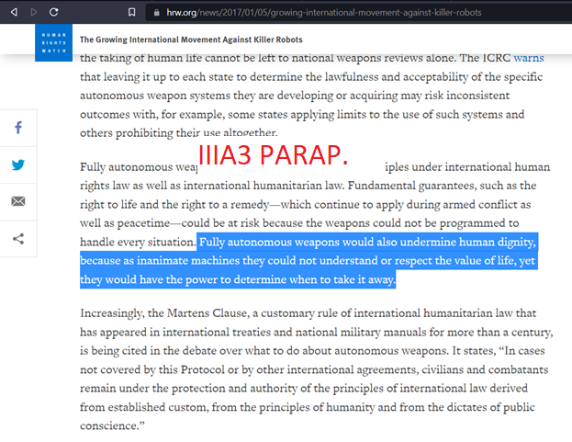

Definition of autonomous weapons (Allen, 2022)

Autonomous weapons can be defined in different ways, but the most common definition is a weapon system that once triggered, is capable of selecting and engaging targets without additional assistance from a human operator (Allen, 2022).

Introduction Paraphrase

Original text:

Autonomous weapon system: A weapon system that, once activated, can select and engage targets without further intervention by a human operator.

